9.100: Following the procedure used in Example 9.14 (and using z as the coordinate along the vertical axis)

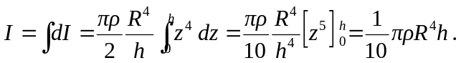

The volume of a right circular cone is 